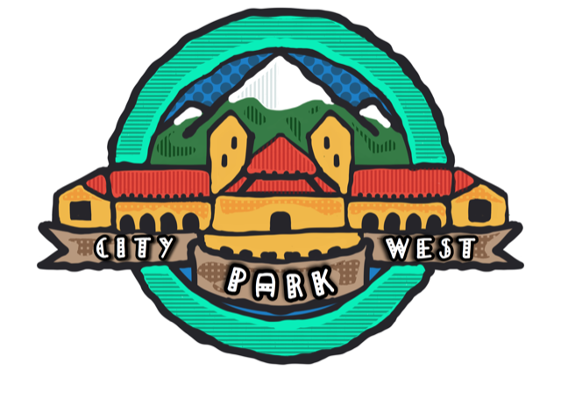
BOARD MEETING AGENDA
December 18, 2019; 6:00pm
Location: Mary Russell Pavilion Saint Joseph Hospital

- Call to Order – Roll Call
- Approval of Minutes
- Treasurer Report
  - Reconciled Bank
  - INC bill
  - Budget
- Membership, Member Planet, Fundraising
- Denver Police Department Update
- Communications Update – Website, Facebook, brochure
- East Central Area Plan
- Establishment of Zoning Committee
- Sherman Street
- Other Business
  - Overlap of RNO
- Adjournment

