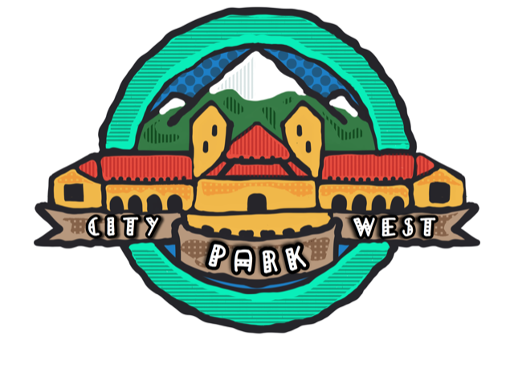

Public Input Session
2321 ½ Gaylord
January 13,2021

City Park West RNO is the area from York to Downing, 23rd to Colfax
There are 32 dues paying members of the organization.
Flyers about this public input session were distributed to neighbors on York, Gaylord and Race from 23rd to 19^{th –} Approximately 100 flyers

There were four attendees at this meeting (held virtually) including the owner of the property

The owner explained they were utilizing an existing stable building for home built in 1890. They hope to make this structure an ADU with entrance through the yard of the home and not alley. Current zoning requires ADU to be on opposite side of lot which would be closer to immediate neighbor than existing building. They are not increasing the footprint of structure.

No one in attendance had any issues with this proposal and therefore support the proposal.

Jo Untiedt, President CPW

Public Input Session
2001 York Street Demolition Application
January 13,2021
City Park West RNO

City Park West RNO is the area from York to Downing, 23rd to Colfax
There are 32 dues paying members of the organization.
Flyers about this public input session were distributed to neighbors on York, Gaylord and Race from 23rd to 19th

There were six people in attendance including the owner.

The group discussed the design of the building as post modern. The owner explained that he purchased the property from Dottie Bruton had the opportunity to learn about her husband Bertram – one of the first black architects of Denver who offices in this building.

The current plan for owner is to construct maximum of six townhomes of which 2 will believe/work units. There will be a parking space for each unit and three additional parking spaces the owner hopes to design these as a brownstone

CPW Board members Jo Untiedt and Scott Holder explained the desire to pay tribute to Mr. Bruton.
A neighbor suggested possible using roof line in current design for brownstones.

There was discussion that the building itself was not of great interest, but the history should be preserved.

The owner will continue to communicate with CPW. It is possible we can engage CHFA to assist with a tribute as Ms. Bruton was a board member for several years.

